Rossett Acre Primary School
2026 Leavers Hoodie Order Form

PLEASE PRINT
 | First Name: | Surname:
 | First name/nickname for back of hoodie: | Initials on right chest (leave blank if not required):
 | Size (Please choose either a child or adult hoodie and tick the size required)
 | JH001B Child
 | 12-13
 | JH001 Adult
 | Small: - |  | Large: -
 | Medium: - |  | XL: -

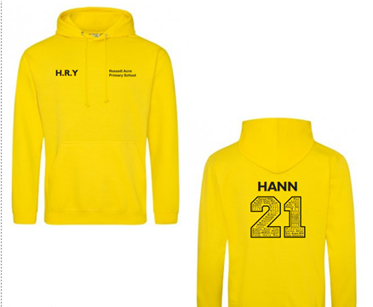
Price: £13.05 for children’s / £14.35 for adult sizes

Rossett Acre Primary School
2026 Additional Leavers Hoodie Order Form

PLEASE PRINT
 | First Name: | Surname:
 | First name/nickname for back of hoodie: | Initials on right chest (leave blank if not required):
 | Size (Please choose either a child or adult hoodie and tick the size required)
 | JH001B Child
 | 12-13
 | JH001 Adult
 | Small: - |  | Large: -
 | Medium: - |  | XL: -

Price: £26.10 for children’s / £28.70 for adult size

